Experiment 3 - E-Commerce Mobile App Prototype using Figma

Aim:
To create a prototype of an E-Commerce mobile application using Figma to discuss the user interface with stakeholders and collect their feedback for approval.

Tool Uses: Figma
Description:
The prototype represents a simple E-Commerce mobile application. It provides a user-friendly interface for browsing products, viewing product details, adding products to the cart, and placing orders. The prototype helps stakeholders visualize the application before development.

Screens Designed:
- Splash Screen
- Login Screen
- Home Screen
- Product Details Screen
- Shopping Cart Screen
- Checkout Screen
- Order Confirmation Screen

Workflow:
1. User opens the application.
2. User logs into the account.
3. User browses available products.
4. User views product details.
5. User adds products to the shopping cart.
6. User proceeds to checkout.
7. User places the order.
8. Order confirmation is displayed.
Features:
User Login
Product Search
Product Categories
Product Details
Add to Cart
Secure Checkout
Order Confirmation

Stakeholder Feedback:
- The prototype can be reviewed by stakeholders to provide suggestions regarding:
- User Interface Design
- Navigation Flow
- Screen Layout
- Button Placement
- Color Theme
- Overall User Experience
Result:
The E-Commerce mobile application prototype was successfully created using Figma. The design can be used to gather stakeholder feedback before implementation.

Output:
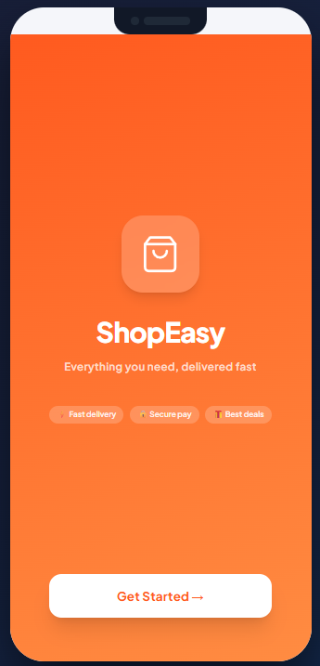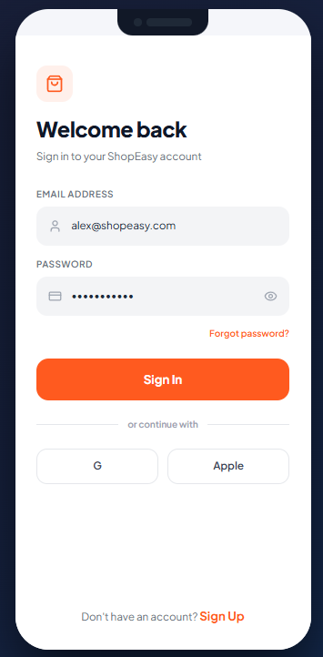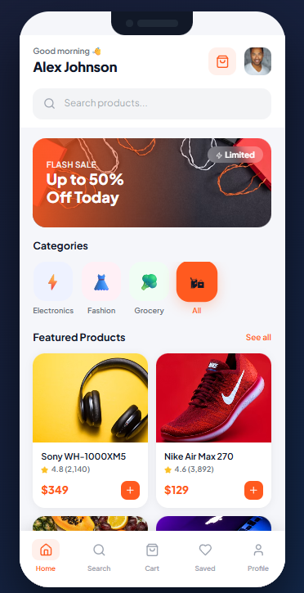
1.Starting page 2.User Login Page 3. Home page

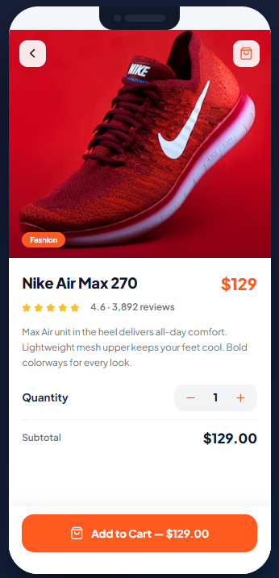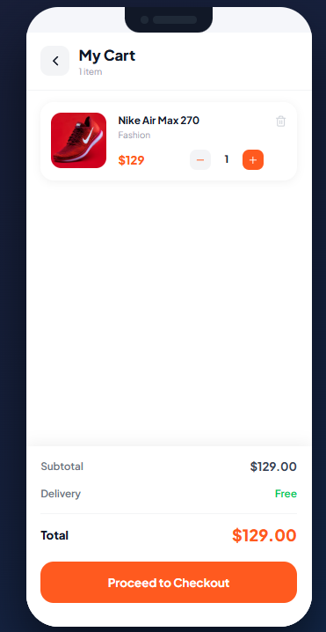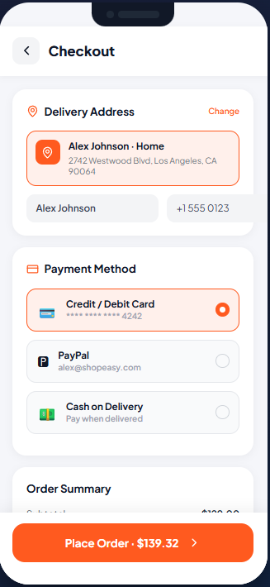
4. Product Details 5. Shopping Cart 6. Checkout

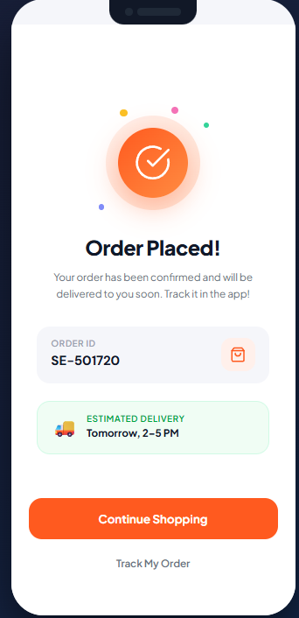
7. Order Confirmation

